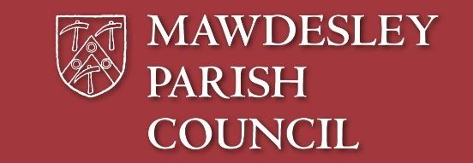

**NW Ambulance Service are offering a**

**free introductory session on how to use the defibrillator**

**on**

**Sunday 4th December**

**1.00 to 2.30pm**

**at Mawdesley Village Hall**

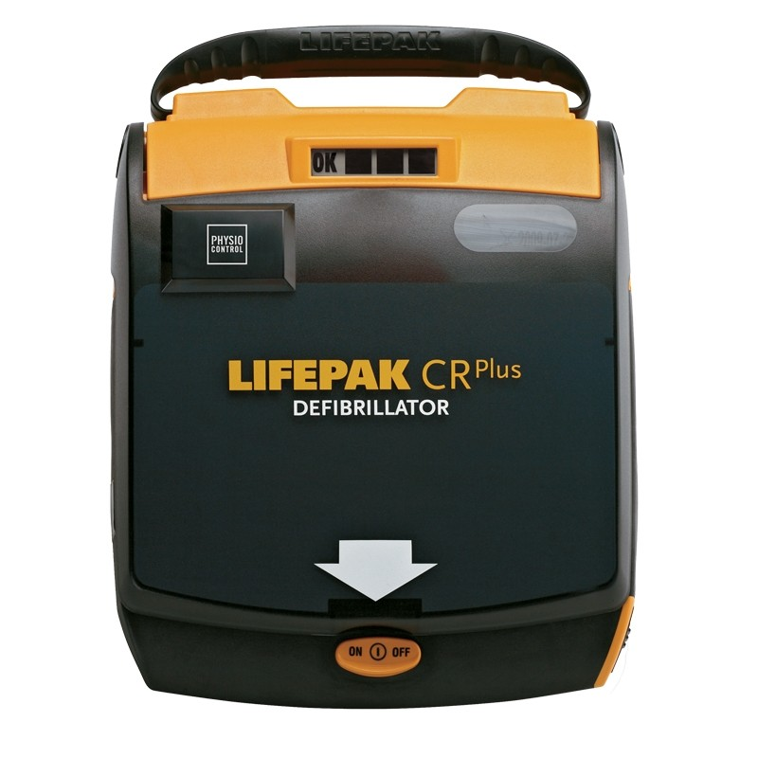**Defibrillator training will give you the confidence to act quickly and effectively if someone has a cardiac arrest.**

**You will learn how to become familiar with the defibrillator and learn how to operate it in a friendly and supportive environment.**

**No previous knowledge is required.**

**To book your place (spaces are limited) please e mail the Parish Clerk on** [**clerk@mawdesleyparishcouncil.org.uk**](mailto:clerk@mawdesleyparishcouncil.org.uk) **or drop your contact details in the letter box at the side of the SPAR**