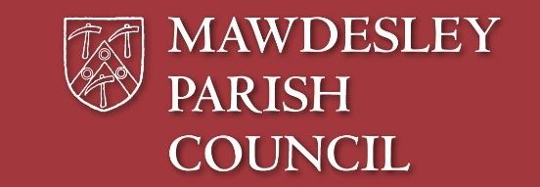

**We have a vacancy for a Parish Councillor, and we’d love to hear from you**

* **Do you want to serve your Community?**
* **Do you have time or expertise which could benefit your Community?**
* **Do you want to make a difference to all those around you?**
* **Are you concerned about your local area?**
* **Do you want to represent the views of local people?**

**If you would like to make a difference, and be involved in shaping the future of your local community, why not step forward and apply to become a Mawdesley Parish Councillor?**

**If you are interested in applying or would like more information, please contact our Parish Clerk, Trish Grimshaw at** [**clerk@mawdesleyparishcouncil.org.uk**](mailto:clerk@mawdesleyparishcouncil.org.uk)

**The closing date for applications to be with the Clerk is**

**9am on Tuesday 31st May 2022**

To qualify to become a Parish Councillor a person must be a British subject over 18 years old, be listed on the current electoral role, live in Mawdesley, or within 3 miles of its boundary (or occupy as owner/tenant any land/premises therein or have a principal place of work within the Parish) and must not be disqualified from holding office as a Councillor.