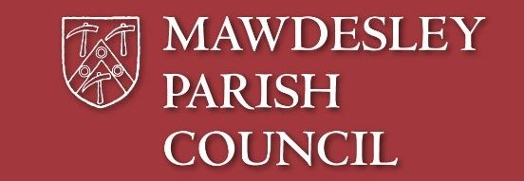

**Mawdesley Community Clean Up Day**

**Saturday 3rd September 2022,**

**9.30am to 12 noon**

**On the car park at Mawdesley Village Hall**

Please bring your unwanted items to place in the skip at the village hall car park.

If you need assistance or have a heavy item, you can book these in for the neighbourhood officers from Chorley council to call round and collect on the morning of 3rd September.

Please note this service is offered to residents who would struggle to get items to the skip themselves and must be booked in advance by e mailing:

[clerk@mawdesleyparishcouncil.org.uk](mailto:clerk@mawdesleyparishcouncil.org.uk) no later than Wednesday 31st August providing details of items to be collected and address including postcode.